# Page 3

This should page page 3.

## Proof that Oracle hates Java

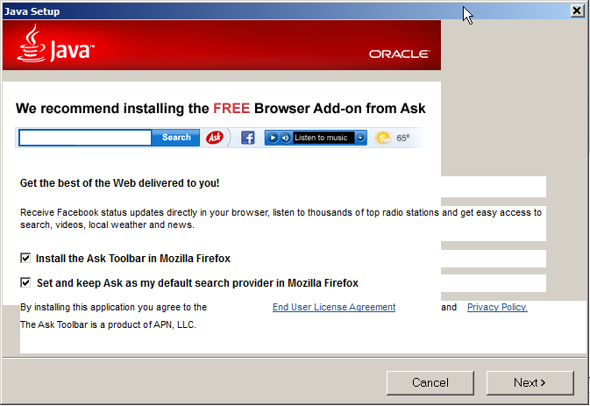

## This is actually a table:

|  |  |  |  |
| --- | --- | --- | --- |
| 1 | 2 | 3 | 4 |
| 5 | 6 | 7 | 8 |
| 9 | 10 | 11 | 12 |